**COVER PAGE**

**You will edit here**

**The name is Helping Hands**

**TABLE OF CONTENT**

You will also edit here

**Physical ERD**

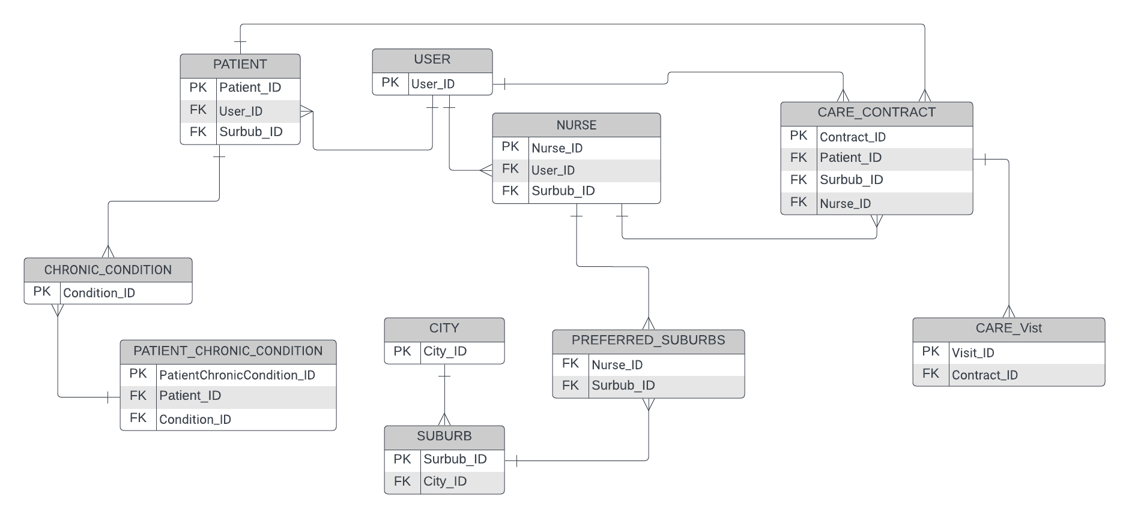

**Data Dictionary**

User Table

|  |  |  |  |  |
| --- | --- | --- | --- | --- |
| **USER** | | | | |
| **Attribute** | **Data Type** | **Length** | **Validation & UI Control** | **Business Rules** |
| User_ID | AutoNumber | 11 | Mandatory. Integers only.  TextBox | Primary Key. Must be  unique. |
| Last_name | String | 255 | Mandatory TextBox | This field represents the last name of the user and must be provided by the user |
| First_name | String | 255 | Mandatory TextBox | This field represents the first name of the user and must be provided by the user |
| Email_address | String | 55 | Mandatory TextBox: Special Characters | This field holds the email address of the user and must be provided by the user. Special characters are allowed to create valid email addresses. |
| Contact_no | Number | 10 | Mandatory TextBox: Numbers only | This field stores the contact number of the user and must be provided by the user. Only numeric values are allowed. |
| User_type | String | 1 | Mandatory | This field represents the type of user (e.g., A for ADMIN, O for OFFICE MANAGER, P for PATIENT, N for NURSE) and must be provided by the user. It helps in distinguishing different types of users in the system. |

Patient Table

|  |  |  |  |  |
| --- | --- | --- | --- | --- |
| **PATIENT** | | | | |
| **Attribute** | **Data Type** | **Length** | **Validation & UI Control** | **Business Rules** |
| Patient_ID | AutoNumber | 11 | Mandatory. Integers only.  TextBox | Primary Key. Must be unique. |
| User_ID | Number | 255 | Mandatory TextBox | Foreign Key to User table |
| Gender | String | 1 | Mandatory dropdown | Single character code: M (Male), F (Female), O (Other) |
| ID_Number | Number | 13 | Mandatory TextBox: Numbers only (Intergers) | Unique identification number for the patient |
| Date_of_Birth | Date | 10 | Mandatory TextBox: Numbers only (Autogenrated from ID_NUMBER) | Date of birth for the patient |
| Surburb_ID | String | 1 | Mandatory; Drop down | Address where the patient resides |
| Emergency_Contact_Person | String | 255 | Mandatory; textbox | Name of the person to contact in emergencies |
| Emergency_Contact_Number | Number | 10 | Mandatory; textbox, intergers only | Contact number of the emergency contact person |
| Additional_Information | String | 255 |  | Any additional information about the patient |

Nurse Table

|  |  |  |  |  |
| --- | --- | --- | --- | --- |
| **NURSE** | | | | |
| **Attribute** | **Data Type** | **Length** | **Validation & UI Control** | **Business Rules** |
| Nurse_ID | AutoNumber | 11 | Mandatory. Integers only.  TextBox | Primary Key. Must be unique. |
| User_ID | Number | 255 | Mandatory TextBox | Foreign Key to User table |
| Nurse_Code | String | 11 | Mandatory, TextBox | Code to identify the nurse |
| Gender | String | 1 | Mandatory dropdown | Single character code: M (Male), F (Female), O (Other) |
| Email_address | String | 255 | Mandatory: textbox | Email address of the nurse |
| ID_Number | Number | 13 | Mandatory TextBox: Numbers only (Intergers) | Unique identification number for the nurse |
| Date_of_Birth | Date | 10 | Mandatory TextBox: Numbers only (Autogenrated from ID_NUMBER) | Date of birth for the nurse |
| Surburb_ID | String | 1 | Mandatory; Drop down | Address where the nurse resides |
| Emergency_Contact_Person | String | 255 | Mandatory; textbox | Name of the person to contact in emergencies |
| Emergency_Contact_Number | Number | 10 | Mandatory; textbox, intergers only | Contact number of the emergency contact person |

Chronic Condition Table

|  |  |  |  |  |
| --- | --- | --- | --- | --- |
| **CHRONIC_CONDITION** | | | | |
| **Attribute** | **Data Type** | **Length** | **Validation & UI Control** | **Business Rules** |
| Condition_ID | AutoNumber | 11 | Mandatory. Integers only.  TextBox | Primary Key. Must be unique. |
| Condition_Name | String | 255 | Mandatory TextBox | Name of the chronic condition |
| Description | String | 255 | Mandatory, TextBox | Description of the chronic condition |

Patient Chronic Condition Table

|  |  |  |  |  |
| --- | --- | --- | --- | --- |
| **PatientChronicCondition** | | | | |
| **Attribute** | **Data Type** | **Length** | **Validation & UI Control** | **Business Rules** |
| Patient_ID | Number | 11 | Mandatory Textbox | Foreign Key to Patient table |
| Condition_ID | Number | 11 | Mandatory, Textbox | Foreign Key to Chronic Condition table |

City Table

|  |  |  |  |  |
| --- | --- | --- | --- | --- |
| **City** | | | | |
| **Attribute** | **Data Type** | **Length** | **Validation & UI Control** | **Business Rules** |
| City_ID | AutoNumber | 11 | Mandatory, Integers only | TextBox, Primary Key, must be unique |
| City_Abbreviation | Number | 11 | Mandatory TextBox | Foreign Key to Patient table |
| City_Name | Number | 11 | Mandatory, TextBox | Foreign Key to Chronic Condition table |

Suburb Table

|  |  |  |  |  |
| --- | --- | --- | --- | --- |
| **SUBURB** | | | | |
| **Attribute** | **Data Type** | **Length** | **Validation & UI Control** | **Business Rules** |
| Suburb_ID | AutoNumber | 11 | Mandatory. Integers only.  TextBox | Primary Key. Must be unique. |
| Suburb_Name | String | 255 | Mandatory TextBox | Name of the suburb |
| Postal_Code | String | 1 | Mandatory textbox | Postal code of the suburb |
| City_ID | Number | 11 | Mandatory TextBox: Numbers only (Integers) | Foreign Key to City table |

Care Contract Table

|  |  |  |  |  |
| --- | --- | --- | --- | --- |
| **CARE_CONTRACT** | | | | |
| **Attribute** | **Data Type** | **Length** | **Validation & UI Control** | **Business Rules** |
| Contract_Number | AutoNumber | 11 | Mandatory. Integers only.  TextBox | Primary Key. Must be unique. |
| Contract_Date | String | 255 | Mandatory TextBox | Name of the suburb |
| Patient_ID | String | 1 | Mandatory textbox | Postal code of the suburb |
| City_ID | Number | 11 | Mandatory TextBox: Numbers only (Integers) | Foreign Key to City table |
| Wound_Description | String | 255 | Mandatory: Textbox | Description of the patient's wound |
| Start_Care_Date | Date | 10 | Mandatory: Datepicker | Start date of the care contract |
| End_Care_Date | Date | 10 | Mandatory: Datepicker | End date of the care contract |
| Nurse_ID | Number | 11 | Number | Foreign Key to Nurse table |
| Contract_Status | String | 255 | Mandatory: Textbox | Single character code: N (New), A (Assigned), C (Closed) |

Care Visit Table

|  |  |  |  |  |
| --- | --- | --- | --- | --- |
| **CARE_VISIT** | | | | |
| **Attribute** | **Data Type** | **Length** | **Validation & UI Control** | **Business Rules** |
| Visit_ID | AutoNumber | 11 | Mandatory. Integers only.  TextBox | TextBox, Primary Key, Must be unique |
| Contract_Number | Numebr | 11 | Mandatory | Foreign Key to Care Contract table |
| Visit_Date | Date |  | Editable, DatePicker | Date of the care visit |
| Approx_Arrive_Time | time |  | Editable, TimePicker | Foreign Key to City table Approximate arrival time for the care visit |
| Visit_Arrive_Time | time |  | Editable, TimePicker | Actual arrival time for the care visit |
| Visit_Depart_Time | time |  | Editable, TimePicker | Departure time after the care visit |
| Wound_Condition | String | 255 | Textbox | Description of the wound's condition |
| Notes | String | 255 | Textbox | Additional notes for the care visit |

Preferred Suburbs Table

|  |  |  |  |  |
| --- | --- | --- | --- | --- |
| **PREFERRED_SUBURBS** | | | | |
| **Attribute** | **Data Type** | **Length** | **Validation & UI Control** | **Business Rules** |
| Preferred_ID | AutoNumber | 11 | Mandatory. Integers only.  TextBox | TextBox, Primary Key, Must be unique |
| Nurse_ID | Number | 11 | Mandatory | Foreign Key to Nurse table |
| Suburb_ID | Number | 11 | Mandatory | Foreign Key to Suburb table |